Memento Imago – Project Overview

# Outline of the Game

## Overview:

Memento Imago is a story based, detective, murder mystery game where the player is tasked with discovering which of a set of suspects murdered several members of the L’estrange family.

The player uses the photographs with a device, the ‘Visualizing Camera, to visualize scenes from the photographs (projected by the camera into the real world) so that evidence and clues can be examined closer to correctly determine who committed the murders.

## Core Experiences

* **Deduction**
  + The player uses their sense of deduction to determine, using the evidence and clues they have discovered from within the photographs and rooms of the house, who of the suspects committed the murders.
* **Mystery**
  + The player experiences a sense of mystery while unravelling the story through the photographs and objects of interest.
* **Misdirection**
  + The player experiences misdirection when going into a photograph they believed would produce evidence however there was none left within the scene.

## All Mechanics

* Visualizing Camera
  + Is the main device of the game, used by the player to project recreations into the world corresponding to the photographs placed into the camera.
  + Recreations of the photographs can only occur when the camera is in the same spot the original photograph was taken
    - A visual is provided for the player for the first photograph as a tutorial however aftersounds it’s up to the player to determine where in the house the photograph was taken and line them up to recreate the scene)
* Photographs
  + Dispersed around the house, the photographs are used by the visualizing camera (in the location of where the photo was originally taken) to project a recreation of the photograph into the world so that the play can inspect clues and evidence close to come to a conclusion about which of the suspects committed the crime
  + Photographs can appear within recreations and are the only part of recreations that can be removed from the recreations and stored by the player
* Interacting
  + With the environment (doors, objects, cabinets, drawers, etc)
  + With photographs around the house and in recreations
  + With evidence and clues within recreations
* Voice/Text lines for player’s character commenting on certain objects or scenes including cutscenes

## Story Overview

A police detective has been tasked with uncovering evidence from the murder of the L’estrange family by using photographs left by the person who murdered them. These photographs are able to be used by a recently created device called the ‘Visualization Camera’ to project a recreation of the scene from the photographs thus allowing the close inspection of new evidence and extra photographs to hopefully conclude which of a set of suspects committed these heinous murders.

# Outline of the Level

## Overview of Level

A Modern Minimalist house previously lived in by the L’estrange family, it is now one of the crucial pieces of evidence. The house has been kept the same as it was on the day of the murders (except that the bodies and blood has been removed from the scene). There are two levels with the first floor being a large open area containing a fireplace with some seats, kitchen, a dining area and large windows opening to the backyard. The second floor contains the bedrooms and extra rooms like the cinema and study (the cinema, study, garage, laundry room, 3rd bedroom and both bathrooms have been blocked off as there was no murders that occurred in these rooms and thus are not crucial to the investigation)

## 2D Topographic Maps of Level

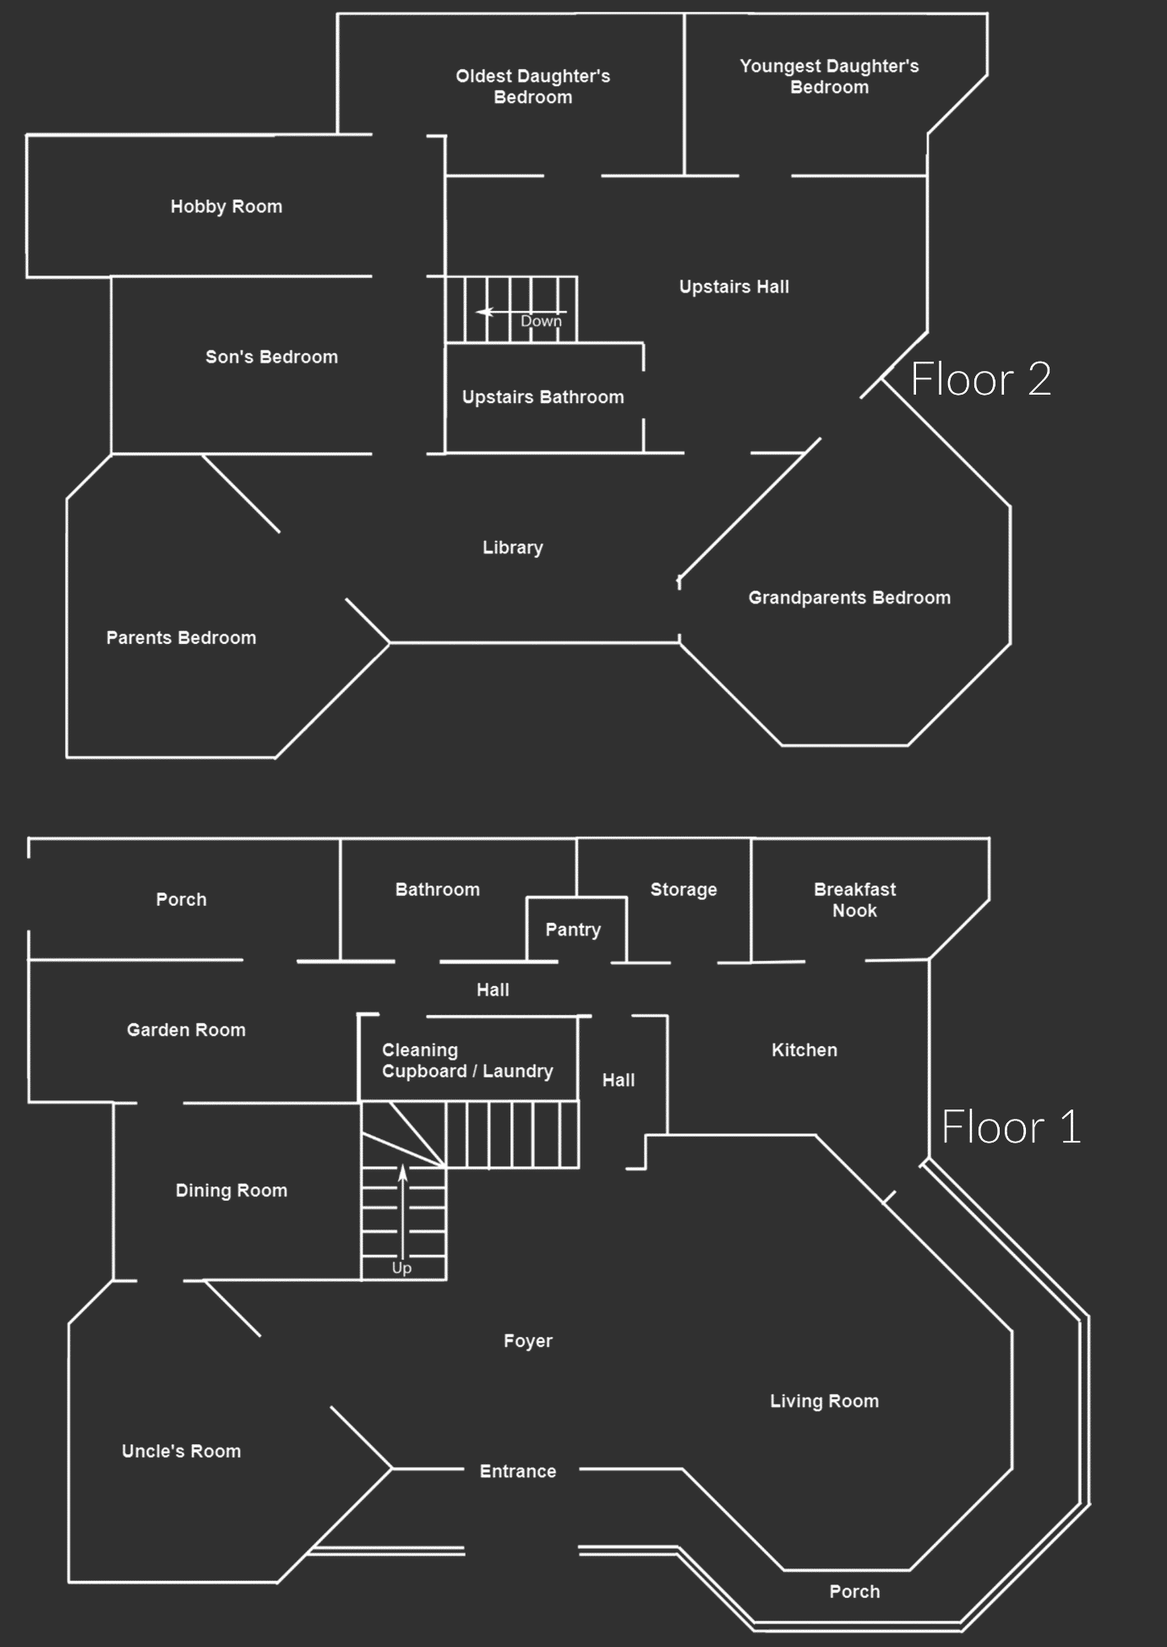

Original House Layout (Iteration 1)

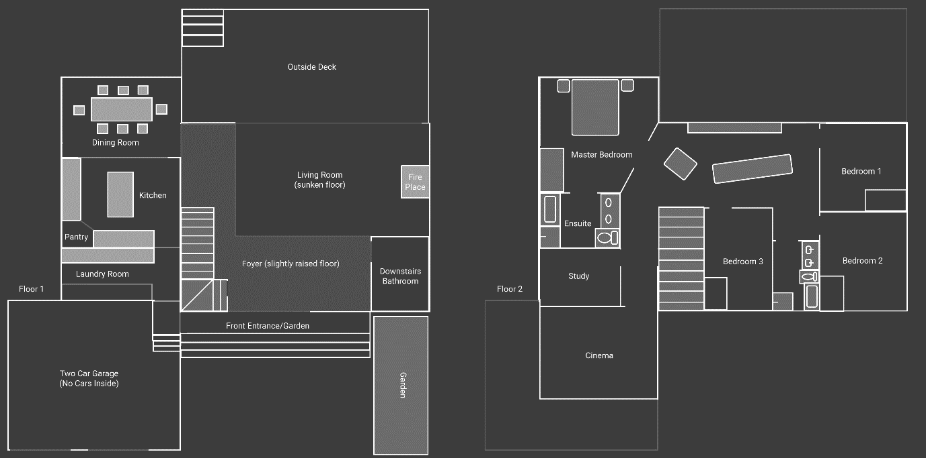

New 2D House Layout (Iteration 2)

**Reason for change:**

Original 2D layout did not fit with the art style and story and had to be changed to a modern minimalist style house resulting in the above new 2D House Layout.

Greybox:

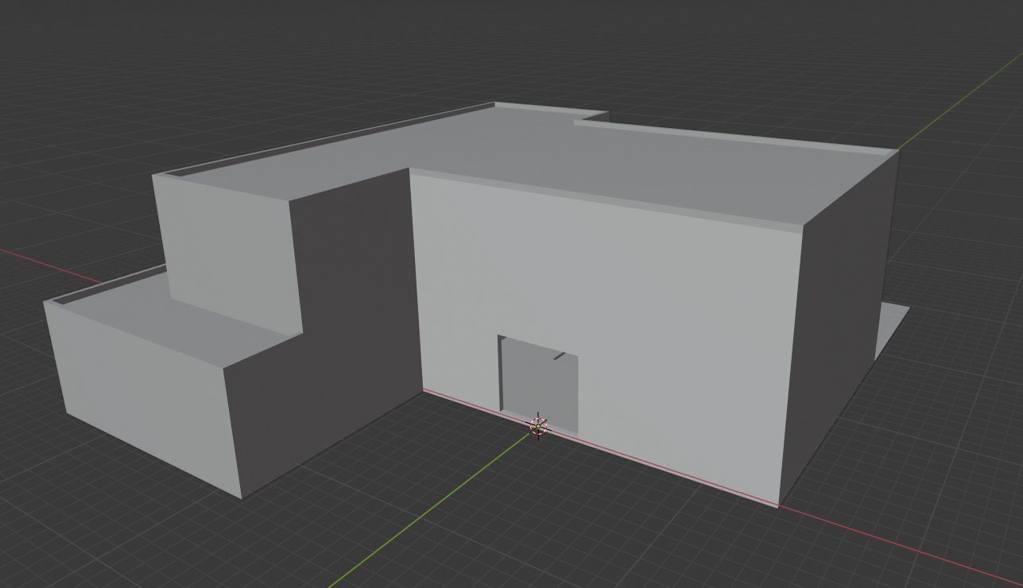

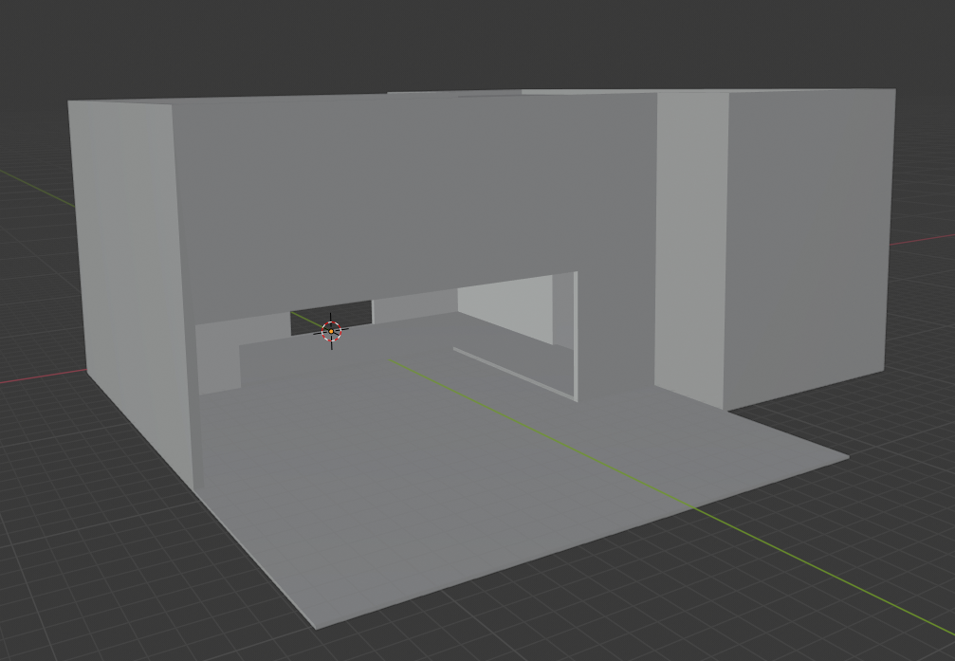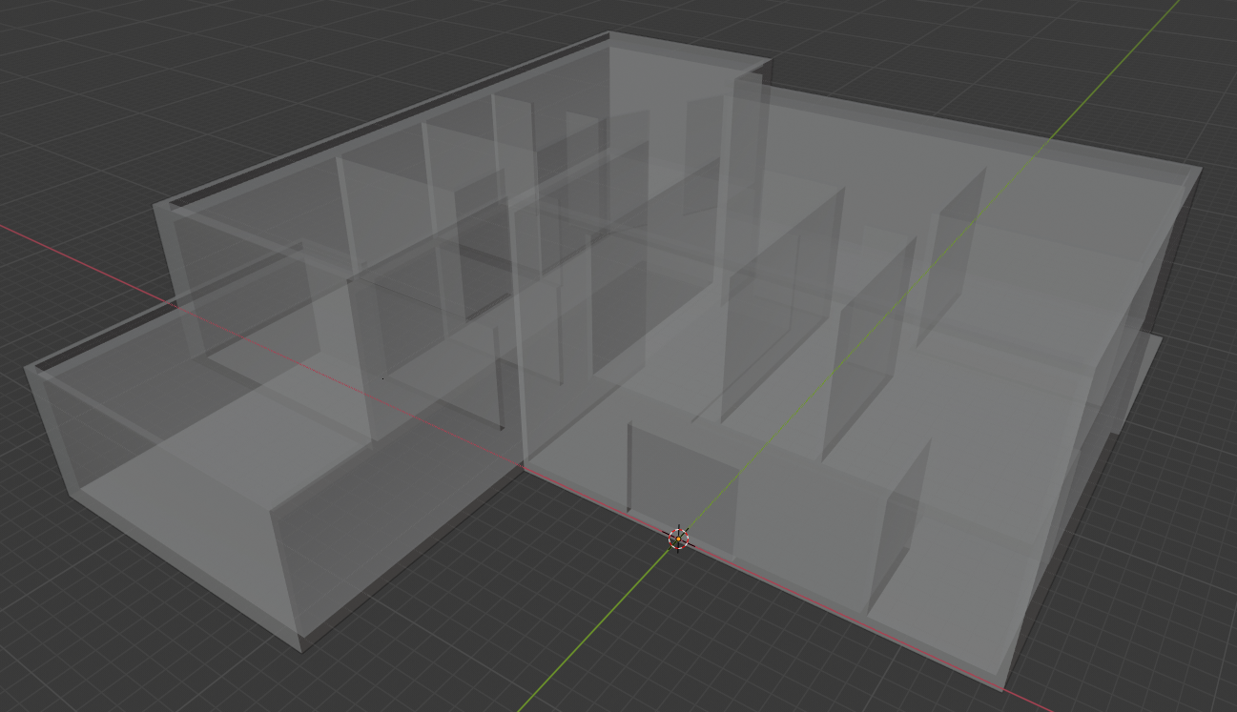

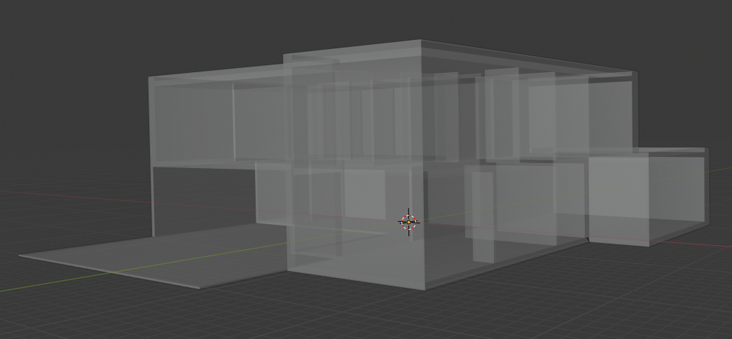

## Narrative Summary of Level

*Beat Sheet provided separately*

* Player walks into the level from the entrance garden and comes across the Visualization Camera and a photograph (a small tutorial explaining how the visualization camera will appear on screen)
* The player uses the Visualization Camera and photographs to recreate the scene from the photograph in the level and thus gain another photograph, from here the game becomes non-linear and it is up to the player to discover all the remaining photographs hidden around the house and within photographs
* The player comes across several murder scenes and uses the clues within the murder scenes to piece together enough evidence to convict one of the several suspects for the crimes of murdering the L’estrange Family in their own house.

## Design Considerations for the Level

* The level must feel like a home and look modern to compliment the art style outlined in the art bible
* Lighting should be diegetic and come from actual light sources and not just be coming from nothing